Working Code

Grumpy Cat Fan Page!

About Grumpy Cat

Tardar Sauce (born April 4, 2012), is a cat and Internet celebrity known for her "grumpy" facial expression, and thus known by the common name Grumpy Cat. Her owner, Tabatha Bundesen, says that her permanently grumpy-looking face is due to an underbite and feline dwarfism.

Grumpy Cat's popularity originated from a picture posted to the social news website Reddit by Bundesen's brother Bryan on September 22, 2012. It was made into an image macro with grumpy captions. As of March 14, 2016, "The Official Grumpy Cat" page on Facebook has over 8.5 million likes. Grumpy Cat was featured on the front page of The Wall Street Journal on May 30, 2013, and on the cover of New York magazine on October 7, 2013.

In August 2015 it was announced that Grumpy Cat would get her own animatronic waxwork at Madame Tussauds in San Francisco. Tardar Sauce has a twin brother named Pokey, who sometimes also appears in Tardar Sauce's memes.

Read more at: <https://en.wikipedia.org/wiki/Grumpy_Cat>

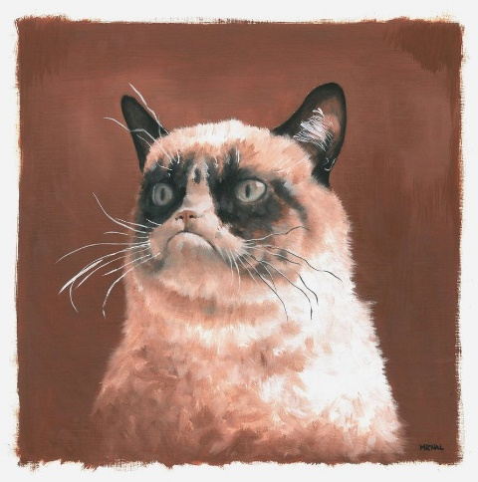

Grow Shrink



Orange Pink Green

Grumpy Cat Rules!

Random Grumpy Cat Fact

Click the button for a random Grumpy Cat fact!

List Of Grumpy Cat's Favorite Things

1. Sleep
2. Food
3. Catnip
4. Pizza
5. Not Liking Things
6. // When the factButton is clicked...
7. $("#factButton").on("click", function() {
8. // We generate a random number between 0 and 4 (the number of facts in the catFactArray)
9. var number = Math.floor((Math.random() * catFactArray.length));
10. // We display the fact from the catFactArray that is in the random position we just generated.
11. $("#factText").text(catFactArray[number])
12. })
13. // This array holds all of our Grumpy Cat facts!
14. var catFactArray = ["Grumpy was born on April 4, 2012", "Grumpy's unique look comes from feline dwarfism and an underbite", "Grumpy has a brother named Pokey", "Her favorite Friskies food is Savory Shreds"]
15. // When the textPink button is pressed...
16. $("#textPink").on("click", function() {
17. // Change funText to pink.
18. $("#funText").css("color", "pink")
19. })
20. // When the textOrange button is pressed...
21. $("#textOrange").on("click", function() {
22. // Change funText to orange.
23. $("#funText").css("color", "orange")
24. })
25. // When the textGreen button is pressed...
26. $("#textGreen").on("click", function() {
27. // Change funText to green.
28. $("#funText").css("color", "green")
29. })
30. // When the boxGrow button is clicked...
31. $("#boxGrow").on("click", function() {
32. // Increase the size of the box.
33. $("#box").animate({height:"+=35px", width:"+=35px"}, "fast");
34. })
35. // When the boxShrink button is clicked...
36. $("#boxShrink").on("click", function() {
37. // Decrease the size of the box.
38. $("#box").animate({height:"-=35px", width:"-=35px"}, "fast");
39. })

.jumbotron {

    background-color: #428bca

}

.jumbotron h1 {

    color:white;

}

p, h1, h4 {

    font-family: 'Roboto Slab', serif;

}

#funText {

    color: black;

    font-size: 24px;

    font-family: 'Roboto Slab', serif;

}

#box {

    height: 100px;

    width: 100px;

    margin:auto;

}

Broken Code

Boo The Dog Fan Page!

Instructions

#### **Oh no! Someone has vandalized our Boo 'The Cutest Dog In The World' fanpage!**

#### **There are a bunch of errors on this page!**

#### **Try your best to find them all!**

About Boo

Boo the dog belongs to a San Francisco-based Facebook employee who created a Facebook page for the dog with a statement "My name is Boo. I am a dog. Life is good." He became popular in October 2010 after singer Ke$ha sent a tweet that she had a new boyfriend, linking to the page. Chronicle Books, noticing that Boo had 5 million Facebook fans at the time, approached the owner to write a picture book. In August 2011, Boo: The Life of the World's Cutest Dog, written by his owner under pen name J.H. Lee, was published. The book was eventually published in ten languages. A second book followed, Boo: Little Dog in the Big City, as well as a calendar and plans for a cut-out book and additional children's books. He also has his own stuffed animal for kids. His merchandise includes a Gund stuffed animal. Boo was appointed a spokesdog for Virgin America airline, which featured photos of him in an airplane along with advice for people traveling with pets. In April 2012, Boo was the subject of a death hoax after #RIPBOO appeared on Facebook. Tweets followed as Gizmodo writer Sam Biddle tweeted Boo had died. It was later confirmed by The Chronicle Book staff that Boo was alive and well. In July 2012, Boo was named the Official Pet Liaison of Virgin America. Read more at: https://en.wikipedia.org/wiki/Boo_(dog)

img class="img-responsive" src="https://img.buzzfeed.com/buzzfeed-static/static/2015-04/21/16/enhanced/webdr05/enhanced-31550-1429646952-7.jpg"

Random Boo Fact

Click the button for a random Boo fact!

List Of Boo's Favorite Things

Dressing Up Eating Grass Sleeping Swimming Hiking

Orange Pink Green

Boo Rules!

Grow Shrink



//When factButton is clicked...

$("#factButton").on("click", function() {

    var number = Math.floor((Math.random() * booFacts.length));

    $("#factText").text(booFacts[number])

})

var booFacts = ["Boo is a pomeranian, Boo's best friend is another pomeranian named Buddy, Boo the Pomeranian was born on March 16, making him a Pisces, Boo's favourite food is grass, Boo has released two books" ]

$("#textPink").on("click", function() {

    $("#funText").css("color", pink)

})

$("#textOrange").on("click", function() {

$("#funText").css("color", "orange")

})

$("#textGreen").on("click", function() {

    $("#funText").css("color", "green")

})

$("#boxGrow").on(click, function() {

    $("#box").animate({height:"+=35px",

        width:"+=35px"}, "fast");

})

$("#boxShrink").on(click, function() {

    $("#box").animate({height:"-=35px", width:"-=35px"}, "fast");

})

.jumbotron {

    background-color: #428bca

}

.jumbotron h1 {

    color:white;

}

p, h1, h4 {

    font-family: 'Roboto Slab', serif;

}

#funText {

    color: black;

    font-size: 24px;

    font-family: 'Roboto Slab', serif;

}

#box {

    height: 100px;

    width: 100px;

    margin:auto;

}